**T.C.**

**BAHÇEŞEHİR UNIVERSITY**



**FACULTY OF ENGINEERING AND NATURAL SCIENCES**

**CAPSTONE FINAL REPORT**

**CROWD-TRACK: REAL-TIME MONITORING AND HEATMAP GENERATION SYSTEM FOR CONFERENCE HALLS**

**Artificial Intelligence Engineering:**

* **Ayah Kouider**
* **Hala Hussein Eltayeb Elmahi**
* **Sandra Hesham Elzeini**

**Electrical and Electronic Engineering**

* **Necati Berkan Şafak**
* **İbrahim Yılmaz**

**Advisors:**

**Prof. Ahmet Arif Ergin, Electrical and Electronic Engineering**

**Prof. Fatih Kahraman, Artificial Intelligence Engineering**

**ISTANBUL, May 2025**

**STUDENT DECLARATION**

By submitting this report, as partial fulfillment of the requirements of the Capstone course, the students promise on penalty of failure of the course that

* they have given credit to and declared (by citation), any work that is not their own (e.g. parts of the report that is copied/pasted from the Internet, design or construction performed by another person, etc.);
* they have not received unpermitted aid for the project design, construction, report or presentation;
* they have not falsely assigned credit for work to another student in the group, and not take credit for work done by another student in the group.

**Key Words**:

# TABLE OF CONTENTS

ABSTRACT iii

TABLE OF CONTENTS iv

LIST OF TABLES v

LIST OF FIGURES v

LIST OF ABBREVIATIONS vi

1. OVERVIEW 7

1.1. Identification of the need 7

1.2. Definition of the problem 7

1.3. Conceptual solutions 9

1.4. Physical architecture 11

2. WORK PLAN 14

2.1. Work Breakdown Structure (WBS) 14

2.2. Responsibility Matrix (RM) 15

2.3. Project Network (PN) 16

2.4. Gantt chart 17

2.5. Costs 20

2.6. Risk assessment 21

3. SUB-SYSTEMS 24

3.1. Electric subsystem 24

3.2. Ai subsystem 27

4. INTEGRATION AND EVALUATION 31

4.1. Integration 31

4.2. Evaluation 31

5. SUMMARY AND CONCLUSION 33

ACKNOWLEDGEMENTS 34

REFERENCES 35

APPENDIX A 36

APPENDIX B 37

# LIST OF TABLES

Table 1. Comparison of the three conceptual solutions. 11

Table 2. Responsibility Matrix for the team 16

Table 4. Costs 20

Table 5. Risk matrix 21

Table 6. Risk assessment 22

# LIST OF FIGURES

Figure 1. Avigilon camera 10

Figure 2. axis camera 11

Figure 3. physical architecture 12

Figure 4. software architecture 12

Figure 5. Work breakdown structure15

Figure 6. The project network. 17

Figure 7. Gantt chart 19

Figure 8.electric architecture 26

Figure 9. Heatmap generation output 39

Figure 10. First Approach 42

Figure 11. Final Approach 42

# LIST OF ABBREVIATIONS

IoT Internet of Things

M2M Machine-to-Machine

IEEE The Institute of Electrical and Electronics Engineers

### Abstract

This project presents crowd-track, a real-time monitoring and heatmap generation system designed for conference halls and similar indoor environments. The system uses object detection to identify and track individuals through surveillance camera feeds. After evaluating multiple deep learning models, YOLOv5 was selected for its high accuracy, fast inference speed, and suitability for human detection in standard indoor scenes. Detected positions are used to generate dynamic heatmaps and analyze crowd movement patterns. The system is optimized for deployment on edge devices such as the NVIDIA Jetson Nano and integrates with tracking modules and a web-based visualization dashboard. This end-to-end pipeline supports effective occupancy management and safety monitoring.

# 1. OVERVIEW

The primary goal of our project is to design and implement a real-time room occupancy monitoring system that tracks the presence and movement of individuals and generates heatmaps for visual analysis. By integrating advanced artificial intelligence techniques with sensor-based detection, the system aims to enhance space utilization and support efficient resource and energy management in environments such as conference rooms, offices, and classrooms.

For the object detection part, we tested several models and finally chose YOLOv5 because it was fast, accurate, and easy to use for detecting people in regular camera footage. It works well with real-time processing on the NVIDIA Jetson Nano, which is important for our setup. The model helps us figure out where people are in the room so we can use that information to create heatmaps that show how crowded different areas get.

By combining expertise in electronics and AI, the team has developed a functional and scalable system designed to improve spatial awareness, occupancy monitoring, and safety.

## 1.1. Identification of the need

The purpose of this project is to create a crowd tracking system for monitoring crowd densities in the conference halls and classrooms of universities. There is little knowledge on how those spaces should be utilized which leads to issues such as inefficient room usage, safety hazards due to overcrowding, and offers data for future references.

The product that will service this problem is an advanced real-time monitoring system which will utilize optical sensors and cameras with fisheye lenses to track individuals entering and exiting the premises. To detect people in the camera footage, an object detection model trained on fisheye images is used. This information is then used to generate a heatmap to visualize crowd density, which will be processed by the NVIDIA Jetson Nano. A web-based application will be developed to view the results and provide data that can be used for future analysis.

## 1.2. Definition of the problem

Managing large spaces such as conference halls and classrooms is difficult without accurate data on occupancy and crowd movement. Existing methods that are currently used include manual monitoring, which is time-consuming and more prone to error, and lacks real-time updates.

This can result in overbooking or underutilizing spaces, which affects users and the experience. Additionally, in emergency situations, not knowing how crowded a space is can imply huge safety risks. To address these issues, our system uses real-time object detection with cameras to automatically track and count people, providing accurate and instant occupancy data.

### 1.2.1. Functional requirements

The system must use optical sensors and fisheye cameras to accurately detect and count individuals entering and exiting conference halls in real time, as well as identify the entrance and exit points in the room. The object detection model, trained on fisheye images, will process the camera feed to recognize people and track their movement. It should provide live occupancy data through an interactive web application interface. To give valuable insights, the system must also generate heatmaps to visualize crowd density and movement patterns in the monitored hall.

The sensors, cameras, and NVIDIA Jetson Nano for data preprocessing must all work together smoothly, enabling the system to function automatically without human assistance. The web application must allow authorized users to view historical trends and analytics, in addition to providing real-time occupancy levels and heatmaps.

### 1.2.2. Performance requirements

The system should be able to reliably detect and count individuals under a variety of lighting and environmental conditions, ensuring consistent performance regardless of the situation. It must generate heatmaps that accurately reflect the current crowd density, providing useful visual insights into how the space is being used. For tracking individuals entering and exiting, the system should process the data in real time with minimal delay, so that occupancy information is always up to date.

The hardware and processing units used in the system should be able to handle the workload efficiently to maintain smooth and continuous operation without causing delays or interruptions. Additionally, the web application should offer a smooth user experience with high availability, minimizing any interruptions to access or data updates. This will allow authorized users to rely on the system for both real-time monitoring and reviewing historical trends.

### 1.2.3. Constraints

To ensure the system can be deployed on a larger scale at colleges and universities without exceeding budget limits, it must be designed to be reasonably priced and use physical components such as the NVIDIA Jetson Nano, optical sensors, and cameras. To reduce environmental impact and maintain reliability in various indoor conditions—such as changing lighting or positioning—it should also be energy efficient.

Additionally, the system must have a user-friendly and non-intrusive design while strictly following GDPR and KVKK regulations to prioritize data security and privacy. The system should be capable of processing data from multiple sensors and cameras quickly and effectively, while being flexible enough to accommodate rooms of different sizes, layouts, and uses.

All hardware and software components should comply with IEEE standards for quality and reliability. Agile development methods should guide the project to allow frequent updates and maintain flexibility throughout the process.

## 1.3. Conceptual solutions

The solutions we developed for creating a crowd tracking system that counts the number of people in a room can be grouped into three main approaches.

The first approach uses a standard setup where the electrical engineering team customizes optical sensors to detect motion and count people entering and exiting. They also install a wide-angle camera at the entrances and a fisheye camera on the ceiling to monitor the room. The sensors and cameras are connected to a microcontroller like an Arduino, which sends the data to the NVIDIA Jetson Nano for processing. On the AI side, the team uses pre-trained models like YOLOv5 for object detection. Using OpenCV, they write simple code to count people and track their movements, and generate basic heatmaps from the fisheye camera data.

The second approach involves the electrical engineering team creating better-customized sensors and adding more cameras to cover the entire room. The data from these sensors and cameras is combined on a small computer like a Raspberry Pi before being sent to the Jetson Nano. The AI team initially tested several advanced models—including YOLOv5, YOLOv8, EfficientDet, and rotated object detection models like R3Det using the MMRotate framework. Although R3Det showed good results on fisheye images with a high mean Average Precision (mAP) of 0.909, the team faced difficulties managing the dataset and integrating it into the system. After overcoming initial challenges with dataset handling in YOLOv5, they chose to proceed with YOLOv5 for its better compatibility and easier implementation. The AI team also uses advanced tracking methods such as the Kalman filter to follow people and generates detailed heatmaps to analyze crowd density.

The third approach uses wireless sensors along with rotating and zoom-capable cameras (PTZ cameras) to focus on busy areas. The data is sent to a central hub. The AI team would process the data using cloud servers such as AWS alongside the Jetson Nano to prevent overheating. They would also add predictive features to estimate peak crowd times.

### 1.3.1. Literature Review

A growing number of industries are using real-time occupancy monitoring systems to effectively manage spaces and guarantee safety. Although the market's current solutions offer cutting-edge technologies, they frequently have drawbacks in terms of price, scalability, and flexibility. An outline of current products, pertinent technologies, and how the suggested concept differs are provided below**.**

The Axis M3058-PLVE Network Camera is a cutting edge fisheye camera developed for crowd

tracking and heatmap generation.that offers 360degree coverage,infrared night vision and preloaded Ai analytics, making it the perfect camera for conference halls,retail establishments and airports.However its high cost and limited customizability restricts accessibility for small scale projects.[1]

Similarly, Avigilon Occupancy Management offers AI driven video analytics that provides us with real-time information on crowd patterns and room capacity[2].Our proposed system aims to address these gaps by utilizing open source tool like TensorFlow,PyTorch and OpenCV,in addition NIVIDIA Jetson Nano for edge computing this cost effective approach includes a web based interface ,live tracking and heatmap generation while complying with GDPR and KVKK regulations, ensuring user privacy.

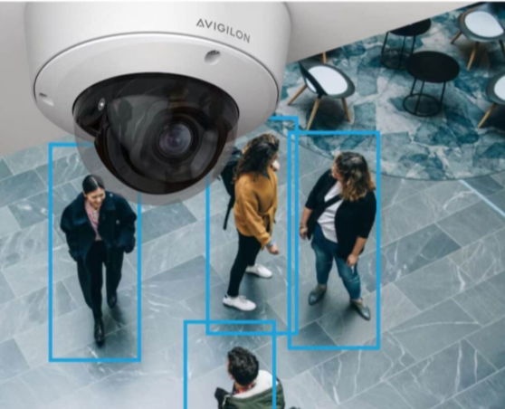 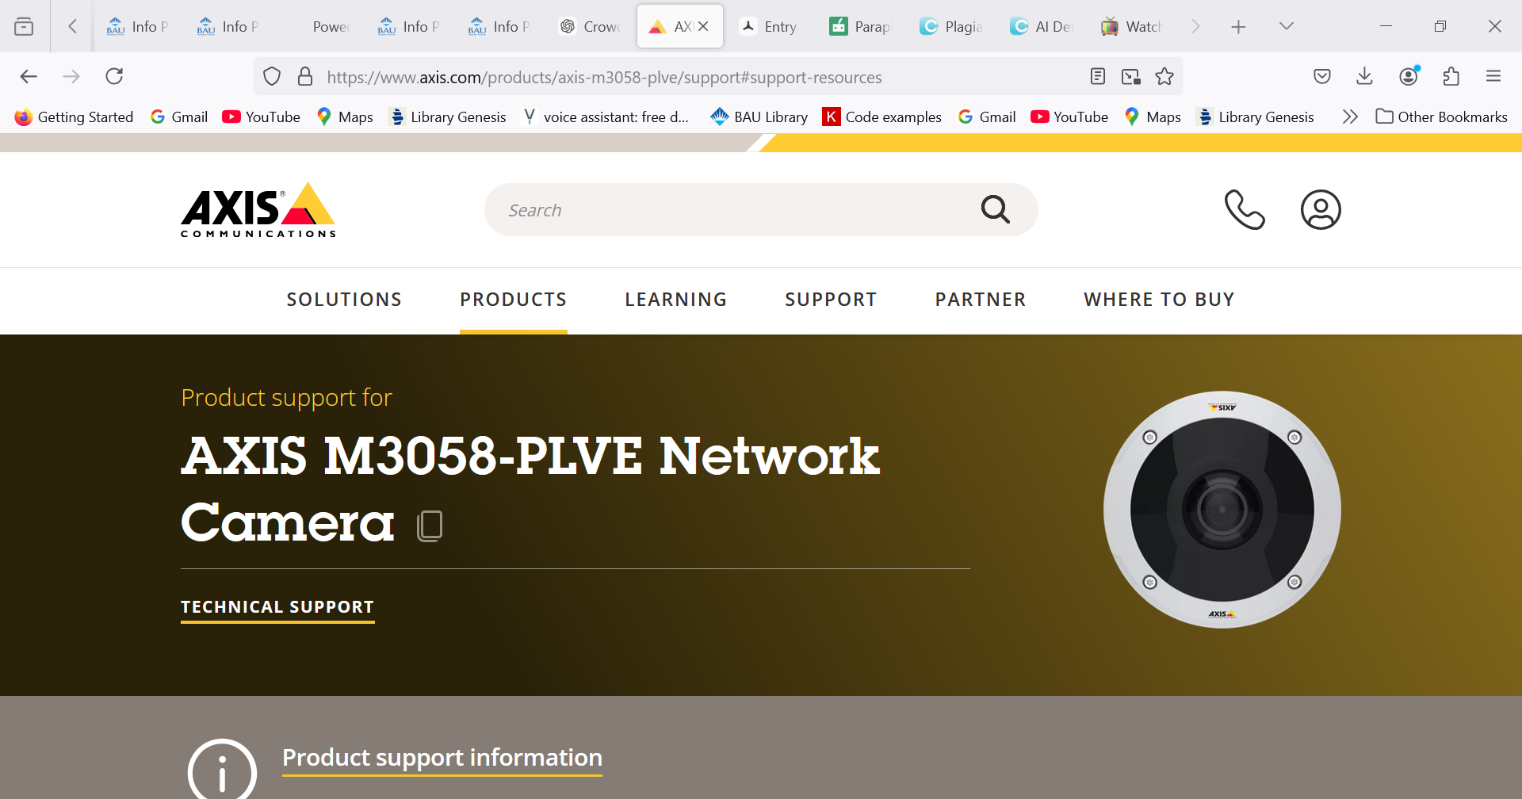 .

**Figure 1:Avigilon camera Figure 2:Axis camera**

**⦁ 1.3.2. Concepts**

The conceptual solutions we came up with are different but share many of the same components, with some adjustments. They all meet the main requirements of the project and can achieve the end goal.

The first solution is straightforward and simple to implement, which increases our chances of success without running into many complications. However, it may not be very accurate because it uses pre-trained models that are not customized specifically for our dataset or environment.

The second solution is cost-effective compared to its potential results and uses a more customized AI model. It performs well, but there is a risk that the NVIDIA Jetson Nano could overheat during heavy processing. Although it requires more advanced tracking methods, this solution strikes a good balance between accuracy and complexity.

The last solution is the most complex and expensive. It offers the best performance and includes all required features, but it also uses more resources than necessary to achieve accuracy.

After considering all options, we decided to go with the second solution. It shows the most potential to reach our goals in an efficient and realistic way. While it may require regular system checks to avoid issues like overheating, this is a small trade-off for a cost-effective and achievable design.

**Table 1. Comparison of the three conceptual solutions.**

|  | Concept 1 | Concept 2 | Concept 3 |
| --- | --- | --- | --- |
| Cost | low | low | high |
| Complexity | low | medium | high |
| Performance | low | medium | high |
| Features | high | high | medium |

Table 1 compares different conceptual solutions with respect to the four most important requirements; Concept 2 is chosen for this project due to its low cost for the end result it may give us, with not much complexity to make it feasible.

## 1.4. Physical architecture

The physical architecture of the system is quite basic as shown in the figure below. The simplicity of the architecture stems from the fact that the system contains only a few parts, the integration between the parts, the code inside the controllers and the positions of these parts are the more complex part of the project. The physical structure for the electrical subsystem contains a camera and sensors which are connected to an Arduino. The data flows forward in the system until the jetson nano and Arduino, these parts can exchange information. For instance, the Arduino might have the wrong person count after a problem with the sensors but the jetson would be able to use the fisheye camera data and correct the count and send it back to the Arduino. Afterwards, the one-way information transfer continues when the jetson sends its data to the server.

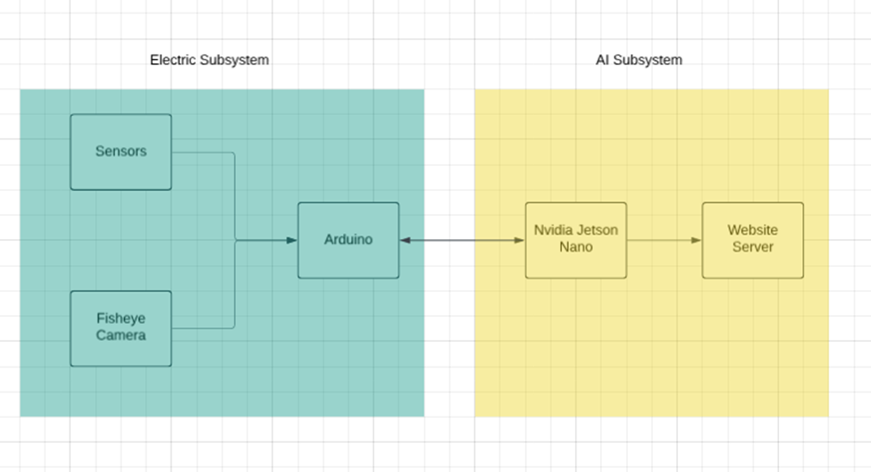

**Figure 3:physical architecture**

The flow of data starts from the cameras and optical sensors, the data is then sent to the Arduino which compiles the data and forwards the compiled data to the jetson nano. The jetson nano is the main processing hub for the system. It processes the visual data from the cameras and detects the individuals and their positions in the target space then a heatmap is generated along with numeric occupancy data. The data is sent to the backend which will be a web-site that displays the live data along with historic data.

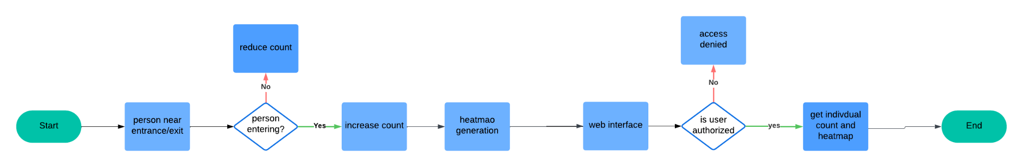

**Figure 4:software architecture**

The system starts and the first flow of the initial data comes from the optical sensors and fish-eye cameras. The sensors are responsible for detecting entrances and exits of people therefore providing a count of real-time occupancy in the target space. The cameras are responsible for providing raw visual data in the room which will be sent to the Arduino which will be connected to both devices. Then, the data will be compiled, and the Arduino will be using the sensor data to create a “person count”, this count and the raw fish-eye camera data will be sent to the jetson and the jetson will be creating a heatmap and confirming the person count with the available data. Afterwards it will be sending the heatmap it created and other necessary data to the backend. This is going to be the stable state of the system where it will be working continuously unless the system has been ordered to turn off. This heatmap and the count will update either after a predetermined amount of time or when the sensors detect a new entry or an exit.

# 2. WORK PLAN

The work plan creates a organized structure that allows to give the group a foundation that helps them with achieving the project requirements. They are used to set the plan of the group and give them a chance to research and understand more about the project that they will perform. It is has different parts to it that covers the main components of the project. They included the parts that needs to be set and decided on in the beginning in order to start working on their system.

The different parts that are underlined in the work plan are guidelines that are uniquely added to help out the students to organize their thoughts and the different ways that they can approach their goal. The work breakdown structure helps emphasize the bigger ideas of the tasks given to each departments and their roles. Th responsibility matrix gives out what each member will be doing and what they have to work on. The project networks shows the flow of the tasks of the project and how each job relates to one another, which helps the member identify the assignments that will need to be worked on together. The grant chartt gives the whole timeline that we will follow which also keeps us up to speed and allows us to stay on time. The costs are there for us to review the items we will be spend money on us which assists us in not going over budget. The risk assessment is their to guide us for the issues that we need to look out for to avoid having troubles in our project

## 2.1. Work Breakdown Structure (WBS)

The work breakdown structure divides the tasks between two main departments: hardware and software. The electrical team is responsible for the hardware components, while the AI team handles the software side. This way, each group knows their specific responsibilities. The tasks are further broken down into three main assignments for each department, and each assignment has specific roles that need to be completed.

The hardware team’s job is to set up the sensors and cameras in the right positions to properly capture the room. Good positioning is important because if the cameras don’t cover the space well, the data will not be accurate. They also have to collect the data from these devices and send it to the software team.

The AI team’s role is to create and choose the best AI model for detecting and tracking people in the room. They tried different models like YOLOv5, YOLOv8, and EfficientDet, but after some difficulties, they finally succeeded using YOLOv5, which worked best with our fisheye camera dataset. Along with this, the AI team is responsible for developing algorithms to track movement and generate heatmaps. They also handle building a web application that shows real-time occupancy and crowd data based on the model’s output.

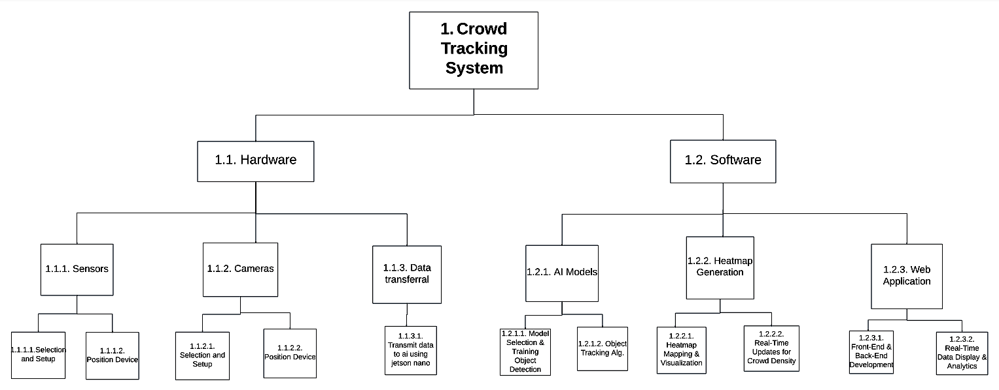

**Figure 5. Work breakdown structure for the project.**

## 2.2. Responsibility Matrix (RM)

The project contains 2 electrical engineering members and 3 AI engineering members. Ibrahim will be responsible for the selection, placement and configuration of the sensors and Berkan will be responsible for placement and configuration of the cameras. Both members will be supporting each other for their respective parts. Sandra will be the main responsible for coding the jetson nano for the heatmap algorithm as well as the object tracking Ayah will work on developing it. Hala will be responsible for creating the web application using the data from the Jetson nano. All AI engineering members will be supporting each other for all AI tasks, the integration part will be a team effort with 1 member from each sub-system being mainly responsible and everyone else supporting it. Ibrahim will be the main person who is responsible for testing but every other member will be supporting him.

**Table 2. Responsibility Matrix for the team**

## 

## 2.3. Project Network (PN)

The project networks outline the project workflow starting with the development of the sensors by the electrical engineering department and setting up the camera and the NIVIDIA jetson nano; these components are integrated as a foundation for the system.Then we move on to the Development of a crowdTracking AI model and web interface that counts the number of individuals and generates heatmaps using an object detection model YOLOv5In the next phase the backend is developed by using flask to ensure smooth connection between the Ai model and the system.In addition to that a front-end application developed using Next.js/React.js, incorporating UI/UX design to ensure a user-friendly interface.Live visualization features are included to display results effectively.The system is deployed with backend and frontend working cohesively and is rigorously tested and evaluated before final submission.

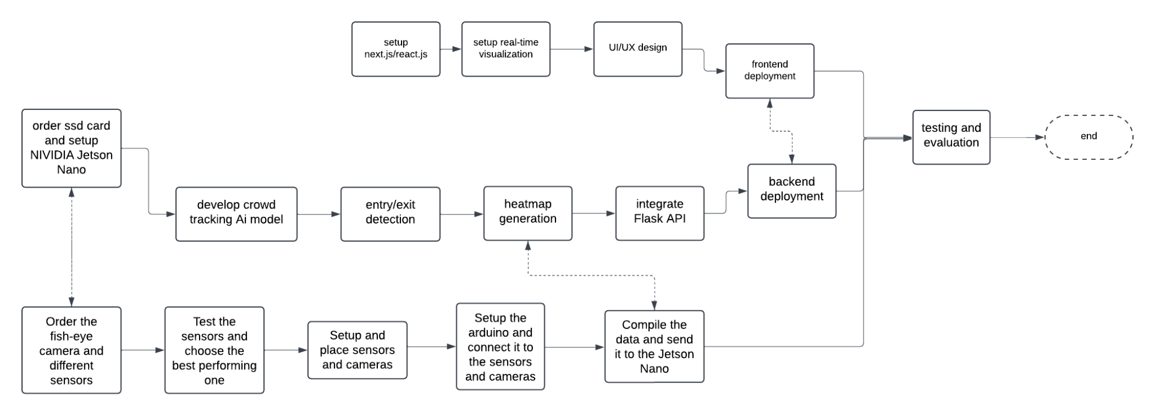

**Figure 6. The project network.**

## 2.4. Gantt chart

In planning the Gantt chart, we were careful to assign realistic start and end times for each task. From Week 1, we decided that early materialization was important for the project's success. We made sure there was enough time to complete each task. We made sure to put the whole team on the same motivation and excitement. For instance, while the Electrical Team began hardware procurement and assembly, the AI Team worked on data collection, and the preparation methods we will follow and preprocessing. We aimed to complete the core product development by Week 10, keeping at least two weeks for verification and troubleshooting. This period is critical to address any unexpected problems that could arise, ensuring that we deliver a reliable and fully functional system. We continued to update our Gantt chart to reflect any changes, ensuring it remained an accurate tool for tracking our activities. Additionally, we created a separate Gantt chart for the first semester, focusing on the design phase.

### Project Timeline:Planning phase: Real-Time Room Occupancy Monitoring and Heatmap Generation

### Discussing Project Expectations (Sep 23 - Oct 6):

### This phase involved finding meetings, aligning schedules, and discussing the project's overall expectations to set a solid foundation.

### First Team Meeting to Distribute Tasks (Oct 8):

### During this meeting, roles and responsibilities were assigned, ensuring every team member understood their tasks to maximize time efficiency.

### Report Writing and Algorithm Development (Oct 16 - Nov 15):

### This phase focused on drafting the initial report, developing algorithms, and preparing datasets to ensure steady progress toward project goals.

### Data Collection and Processing (Nov 17 - Dec 10):

### The team focused on collecting data, cleaning it, and processing it into usable formats for algorithm training and system integration.

### Teacher-Student Meeting (Dec 6):

### A critical checkpoint to present progress to the teacher, gain valuable feedback, and refine the work as needed.

### Online Progress Meetings (Oct 20 - Dec 10):

### Regular virtual meetings ensured consistent alignment, feedback, and resolution of issues during various phases of the project.

### Finalizing Report and Adding Final Touches (Dec 14):

### The final phase focused on refining the report, ensuring all components were complete, and incorporating last-minute details for submission

Materialization phase:

**Data preprocessing and Label correction(week 2-3):**

* All bounding box label files were cleaned and normalized using custom Python scripts.

### Object Detection Model Trials (Week 4–6):

* All bounding box label files were cleaned and normalized using custom Python scripts.
* YOLOv5s model was trained on fisheye data (50 epochs) using Google Colab with GPU acceleration.

**Object Tracking Preparation & Video Conversion (week 4-6)**

* Converted image sequences to video format to support tracking algorithms (e.g., Kalman filter, DeepSORT).
* Identified issues with mismatched formats between YOLO and tracking systems.
* Began converting YOLO detections for compatibility with DeepSORT input.
* Explored alternative tracking models due to fisheye distortion challenges.

**Heatmap generation (7-8):**

* develop a heatmap generation model.

**Web-application development (week 9-10):**

* Designing a RESTful app using flask.

**Enhance object detection model and tracking (week 9-10):**

* Several object detection models were trained and tested, including YOLOv5, YOLOv8, and EfficientDet. At first, these models did not perform well on fisheye camera images and had trouble generalizing to the dataset. Although R3Det (trained with MMRotate) showed the highest accuracy (mAP: 0.909), we faced challenges integrating it smoothly. After further work, YOLOv5 was chosen as the final model because it handled our fisheye data better once properly adjusted and was easier to deploy in real-time tracking.

**Final testing and deployment (11-12):**

* Testing and evaluating the product
* ensuring Ai and electric components work cohesively.

**Final Report and presentation (13-14):**

* Finalize the report
* Present the work while highlighting key challenges and results.

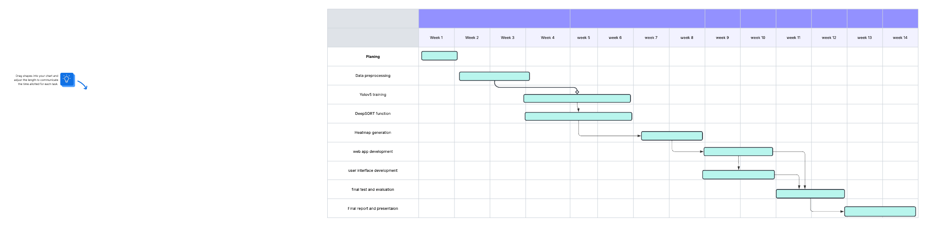

## 2.5. Costs

The projected costs for the crowd tracking system can be divided into 2 subsystems**:optics and sensors subsystem** and **control and communication subsystem.**The optics and sensors subsystem includes the fisheye camera and components necessary for sensor development with a total projected cost of 2070₺ .The control and communication subsystem contains the components needed to operate the NIVIDIA Jetson Nano including the processing unit itself, a 64GB microSD card, a SD card reader and a power adapter with a total projected price of 10,790₺ .The overall cost of the crowd tracking system amount to .Any discrepancies in the between the predicted and actual cost will be addressed in the final report,accounting for potential changes during implementation such as unforeseen upgrades,additional components and price fluctuations.

**Table 4. Costs**

| **Optics and sensors** | |
| --- | --- |
| VGA camera | 200₺ |
| fisheye camera | 1,200₺ |
| LDR sensor | 170₺ |
| Arduino | 500₺ |
| Keyboard | 300 |
| **Total** | **2,370**₺ |
|  | |
| **Communications and Control** | |
| NIVIDIA Jetson Nano | 10,000 ₺ |
| microSD card | 290 ₺ |
| microSD card Reader | 100 ₺ |
| power adapter | 400 ₺ |
| **Total** | **10,790** ₺ |
|  | |
| **System Total** |  |

## 2.6. Risk assessment

Risks of our project are very important to identify and find solutions to avoid them in the future. It gives the chance to plan ahead and be able to work more efficiently. The project that is needed to be worked on is very timely and has a deadline that we must meet, due to that the ability to find the problems that we may face helps reduce the time we need to spend on it. Analyzing the risks helps give a better understanding of the capability of your components and their advantages and disadvantages.

To mitigate these risks, we have to come up with plans on how to solve them. For the hardware components they will have to be tested individually for functionality. In addition, with the software as they have to cohesively work together. Also the software parts need a lot of test trials and feedback sessions. By actively working together and solving the problems beforehand, we will be able to achieve our goal with the least amount of issues.

**Table 5. Risk matrix**

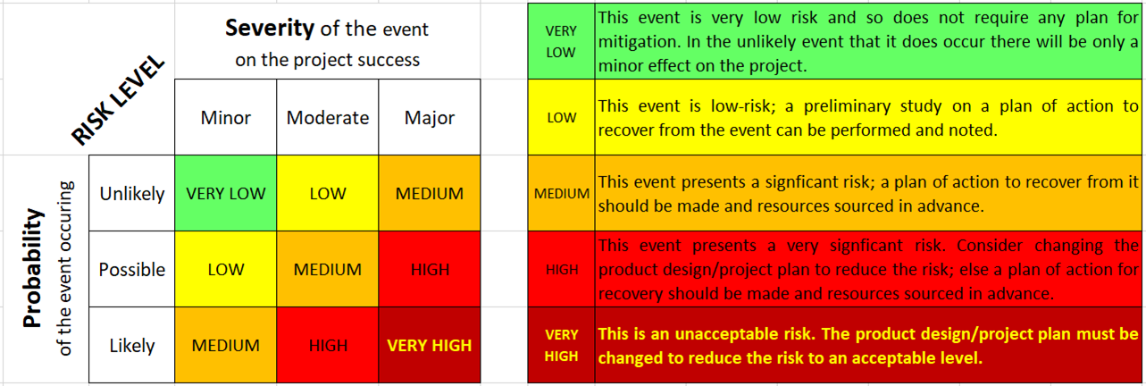

**Table 6. Risk assessment**

| Failure event | Probability | Severity | Risk level | Plan of action |
| --- | --- | --- | --- | --- |
| Sensors does not operate accurately under different lighting | Likely  The sensors work according to the work done on them | Moderate  Requires planning for and adjustment | HIGH | Apply test trials on the sensors under different lightings, mainly dim ones. Adjust the hardware and software components as needed. |
| NIVIDIA Jetson Nano overheats | Possible  The component is unreliable and it could happen with lack of attention | Major  It will affect the whole system from operating | HIGH | The addition of a cooling system or addition of another system to take some weight off the Jetson Nano. |
| The setup of the camera fails to reveal the whole premises | Likely  The positioning of the camera is vital and may not be placed properly first time | Minor  It is easily fixed and can be changed based on our liking | MEDIUM | The group will have to guide each other in order to find the best placement for the camera and with a couple of testing it will work. |
| AI is unable to perform object detection in crowded areas | Possible  AI should be programmed to function under such states and in the case it is not it will not operate as required | Major  This could affect the project outcomes as identifying the people in the room is a requirement | HIGH | Train the AI to operate under crowded area repeatedly until it runs properly. |
| Bad internet connection | Likely  Such occurrences will happen and preparation is important | Moderate  With the right planning it may not cause as much damage to the final result | MEDIUM | Design the product to function offline and be able to store the data until reconnected to the wifi |
| Collected data face privacy problems due to GDPR/KVKK violations | Possible  The rules are placed to be implemented and if not done it will be violated | Major  Not meeting the laws appointed may cause harm to those creating the project | HIGH | Hide the private data that you collect by encrypting it to meet the privacy regulations |
| Difficulties using the web application | Possible  The web application needs to be studied in order for the person utilizing it can work on it | Minor  The issue is solvable and attainable | LOW | Create tests with user and based on their feedbacks adjust the interface |
| Heatmap does not generate quickly | Possible  The algorithms need a lot of testing before reaching your goal | Moderate  It could affect the end result and make them inaccurate | HIGH | Develop faster algorithms to achieve a quicker generation of heatmap of your environment |
| Goes beyond budget | Unlikely  As the products we need for the project are unexpensive | Moderate  of the chance we go over budget we will not reach the required features needed | LOW | Keep track of the products that we are using and the money spent on them. Make sure to take care of the components as not to have to repurchase and add to the costs |

# 3. SUB-SYSTEMS

## 3.1. Electrical Sub-System Development

The hardware features needed for real-time room occupancy monitoring are handled by the Electrical & Electronics subsystem. Using cameras and sensors, this sub-system is in charge of identifying people entering and leaving a room. It also supplies the AI sub-system with accurate and dependable data for processing. To ensure reliable operation in a variety of environmental circumstances, the team's electrical engineers concentrate on hardware-software interfacing, signal processing, and sensor integration.

### 3.1.1. Requirements

There are 2 main functional requirements of the electrical sub-system; the first one is to deliver the AI sub-system with accurate visual data from the fish-eye camera that covers the entire space; the second functional requirement is to have sensors in the entrances of the space to create a live occupancy count which is at least 95% accurate. The sub-system also has some side requirements such as sending compatible data to the Jetson nano that makes the processing easier, and being able to work in different lighting conditions.

### 3.1.2. Technologies and methods

Sun et al. [3] has recently compiled studies on occupancy estimation and counting. These studies have various methods for occupancy estimation and counting, the most common method is a system based on cameras, and this is the main method that is being considered. There are also various methods such as CO2 detection and Pressure detection that Kim et al. [4] have used, however this method was rejected for our system as our system already uses visual data for the fish-eye cameras for the heatmap and using a non-visual sensor would not contribute enough visual data even if the system would correctly provide the correct count. The system would also require ventilation data which would be difficult to acquire.

### 3.1.3. Conceptualization

The camera approach has been chosen for the purpose of the heatmap, the camera would be a fish-eye camera placed on the middle of ceiling in the chosen space. If the space is too big for one camera to

The sensor for the project will not be chosen without sufficient testing in the second semester. The considerations are as follows; The first option is to use LDR sensors at the top of the entrances, these sensors will increase their resistance when a person blocks the light by walking in front of the sensor. These sensors will have to be complemented by a VGA camera that is looking into the entrance. The only purpose for the VGA camera would be to identify facial features belonging to a human to determine if a person is walking into the room or walking out of the room, as this task is simple a high-resolution camera is not needed. This would be a low-cost solution; however, this system would not be able to detect a few edge cases such as a person walking backwards through the door or a person wearing a reflective hat that won’t block the light. This method might also have problems when the lighting in the target space changes. Another option is to use PIR sensors on the entrances to detect movement and use VGA cameras to determine location again. This solution encounters the same issue with people potentially walking backwards, however, the PIR sensor would be more resilient to lighting changes. Lastly, Yun et al. [5] claimed that a 4-PIR sensor rotated at 45-degree increments would be able to determine the movement direction in an open space, if this idea were to be implemented to a door where there would be only 2 potential directions, it would be significantly easier and potentially only require 2 PIR sensors, this method will be tested and considered as the main option if the method works sufficiently.

### 3.1.4. Physical architecture

* + 1. 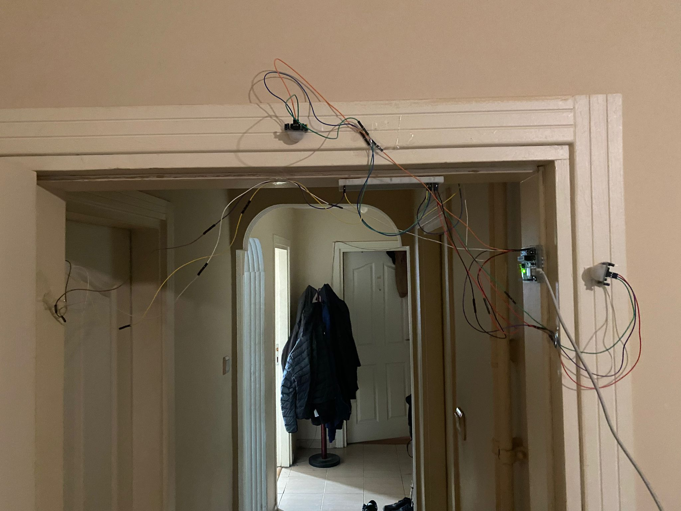
    2. 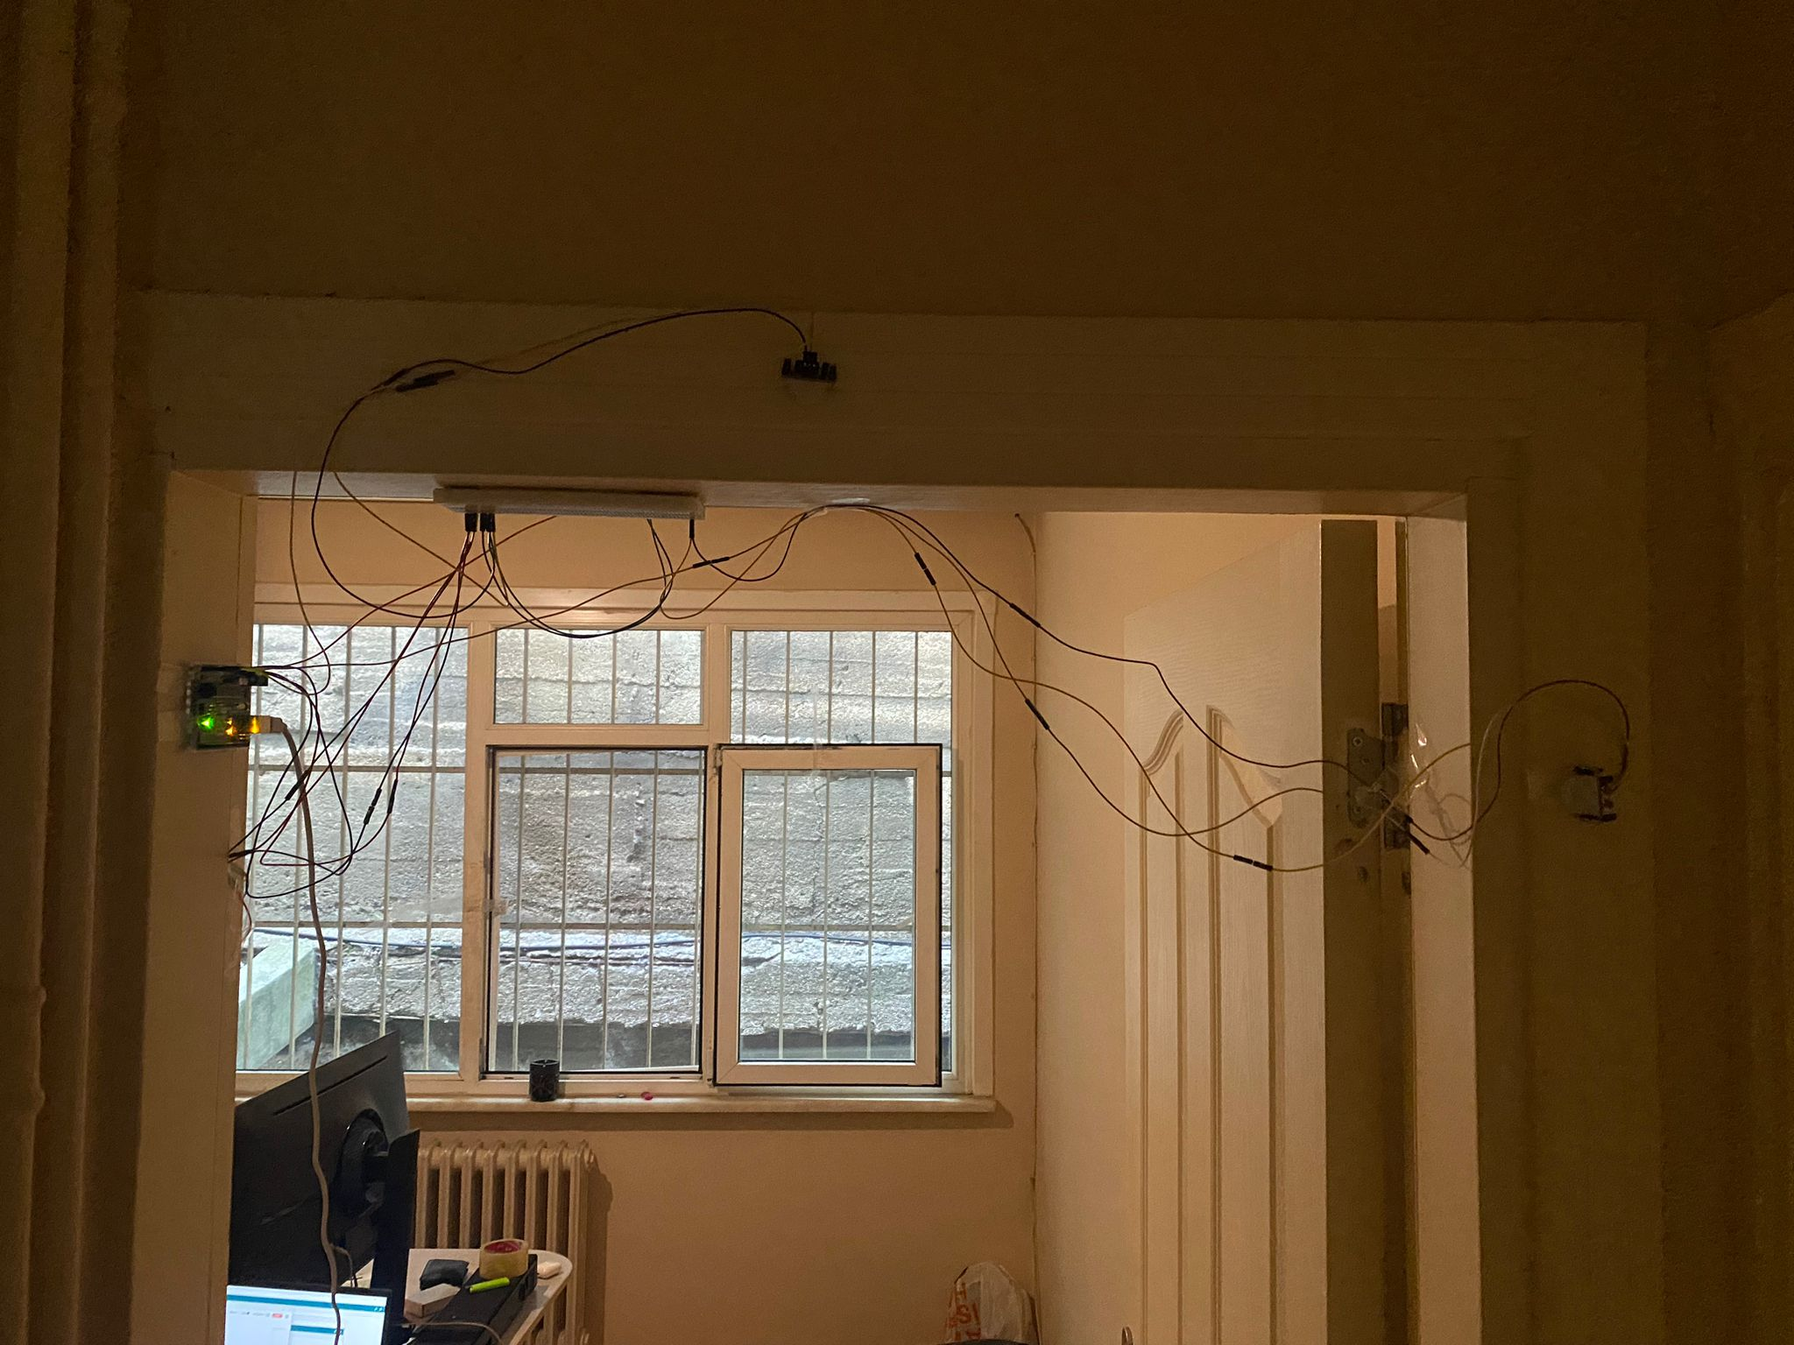**Figure 6:Electric Architecture**

This is the current basic physical architecture for the sensors, the sensors are connected to debug lights in the breadboard to see when they detect movement, this is not going to be in the part of the final product and is for testing purposes. The sensors are connected to arduino’s A2 and A0 ports. They are powered by the 5V socket of the Arduino.

### 3.1.5. Materialization

The plan from the first semester was to experiment with many methods to choose the most capable solution and this resulted in changing the sensor setup and scrapping some ideas. The first scrapped part was the low-resolution camera which would be facing the doorway, another one was the LDR sensor method. The assumption that the 2-sensor method would not be sufficient in the first semester was also correct. The method that we ended up using was 4 PIR sensors although the initial plan was to place them facing 4 different directions to determine the direction, the final method only utilized the extra 2 sensors as confirmation and calculated the direction separately by 2 groups of sensors.

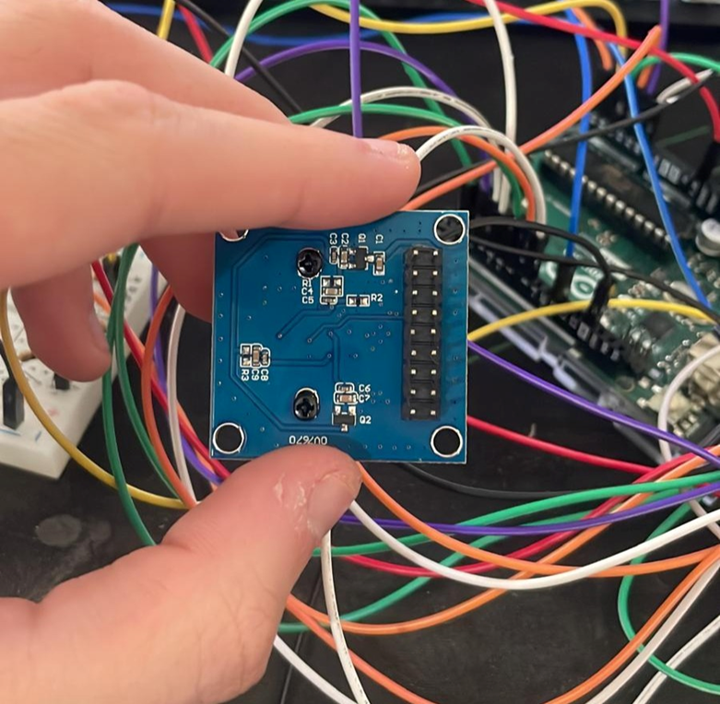

* + 1. **Figure 7: Low Resolution Camera**

The low resolution would have made the confirmation easier and massively increased the accuracy unfortunately, it was not compatible with the arduino uno that was used in the project. OV7670 was the tested camera, technically the camera could be connected to the arduino but realistically, it required an external power module and the software part of it ended up being unreasonably difficult. The only working examples of the system were prior to Arduino 2.1 update which rendered them outdated, efforts of modernizing the code and trying to get an image from the camera reached a roadblock when the code started “working” but the resulting image ended up being extremely blurry and unreadable, troubleshooting didn’t point in a straightforward direction resulting furthermore it was also discovered that original Arduino boards have lower bitrate than copy Arduino boards for the camera therefore resulting in either lower resolution or less frames per second. Due to all the reasons above, the low-resolution camera approach was rejected.

The LDR sensor method was rejected immediately when tested. In retrospect, the usage of this method was illogical and impossible. The idea that the sensor would detect a person by the person, disrupting the light and changing the voltage status, failed to consider the vulnerability of the system to environmental noise. When tested, it was fairly evident that this method would not only not work as a standalone system, it also would not be useful as a “verification” to support the other sensors.

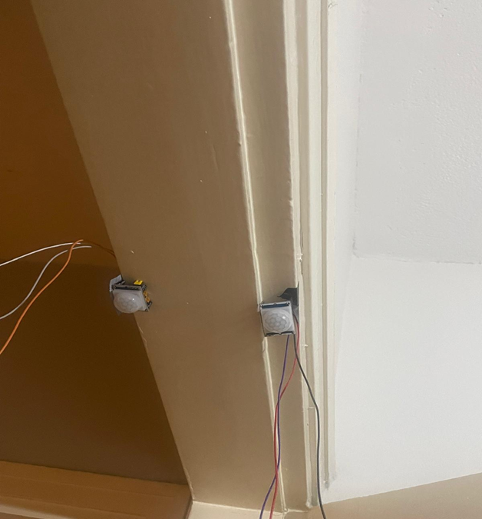

**Figure 8: 2 Sensor Initial Placement**

The 2 PIR sensor method was the first promising method that worked and gave satisfactory results. In the proposal, the sensors were planned to be placed on the edges of the doorframe as can be seen in figure 8. Theoretically, if a person was leaving the first sensor would trigger first followed by the second sensor and the system would have been able to detect an exit. In practice, this was wildly inconsistent although the sensors were identical and had identical response time and detecting range configurations the distance between the sensors was so little that the farther sensor would regularly be the first to detect a leaving person resulting in the system falsely assuming it as an entry and that would deteriorate the count by 2. Various response time and detecting range configurations were tested and none of them resulted in satisfactory accuracy. Afterwards the sensors were moved to the outside of the doorframes as seen in figure 6, this placement stopped their line of sight from interjecting. This placement had both higher accuracy and less punishing mistakes. A wrong reading where one of the sensors failed to detect a person only deteriorated the count by 1 rather than 2. Nevertheless, the false order problem still came up in a different way. The sensors had an internal “cooldown” period after they turned off where they would not turn back on for a few milliseconds. This resulted in a case where if a sensor was mistakenly triggered and then turned off and someone walked in during that period the farther sensor would detect it and the near sensor would detect it after the cooldown period was over, essentially creating a repeat of the initial problem. 2 sensors were improved upon rather than rejected with the 4-sensor method due to this limitation.

The 4-sensor method is essentially the 2-sensor method used twice for increased accuracy. The additional sensors are placed on the sides of the door as can be seen from figure 6. These sensors have identical configuration and conditions as the previous sensors. The probability of both the near sensors being on the cooldown period during a person walked in are significantly lower which fixes the main issue with the 2-sensor method and improves its resistance to natural noise. The system is currently on the double confirmation configuration which displays the count where both the separate 2-sensor systems confirmed an entry or exit. This could be changed to a different method such as taking the average of count1 and count2.

### 3.1.6. Evaluation

As some parts had supply issues, the functioning system was obtained behind the schedule therefore testing has not been sufficient to provide satisfactory data from the final 4 sensor setup. The low-resolution camera setup was rejected before the setup could result in any data. The 2-sensor setup did not reach the academic testing stage as the previously mentioned issues were evident from simply the anecdotal tests.

The testing for the 4-sensor setup and the accuracy calculation which was chosen in the project proposal will be added shortly after the final tests are completed.

## 3.2. Ai crowd tracking application

This sub-system is responsible for detecting and counting individuals as well as identifying entry and exit points to track crowd movement. It combines input from sensors and cameras to produce accurate live data, including crowd density and heatmap generation. The output provides insights and analytics on room usage and crowd behavior through a web-based interface. Additionally, the system integrates hardware components with AI models for object detection and tracking to ensure smooth and efficient operation.

### 3.2.1. Requirements

The application must be capable of handling various challenging scenarios, including crowded halls, multiple entry and exit points, as well as changing weather and lighting conditions, without causing significant drops in performance. It should operate smoothly and integrate seamlessly with the NVIDIA Jetson Nano platform and the accompanying web application. A key function of the system is to provide accurate and reliable object detection to identify and count individuals in real time. The system should also effectively track movement patterns to support crowd management. Additionally, it must generate heatmaps that visualize crowd density and update these regularly to help with analyzing space utilization. Overall, the system should deliver timely and consistent live data with minimal delays, ensuring the application remains responsive and informative under different conditions.

### 3.2.2. Technologies and methods

The sub-system uses the NVIDIA Jetson Nano as the main processing unit to perform real-time analysis and computation. Wide-angle and fisheye lens cameras, along with optical and electronic sensors, are employed for tracking individuals and providing comprehensive spatial coverage.

For object detection, the system uses YOLOv5, which was chosen after extensive testing for its effective performance with our dataset. DeepSORT with an improved ReID method is utilized for tracking individuals across frames. Image processing tasks such as frame handling, preprocessing, and heatmap overlay are performed using OpenCV.

To generate heatmaps, the system uses Scikit-learn, Matplotlib, and OpenCV to create real-time grid-based and density-based visualizations.

Finally, the web interface is developed using React.js for the frontend, providing an intuitive platform for live monitoring and visualization. FastAPI is used for the backend to manage API communications and data handling, ensuring a robust and real-time implementation of the system.

### 3.2.3. Conceptualization

Our high-level design breaks the system into 3 conceptual modules: inference, visualization, and integration each optimized for accuracy, latency, cost and maintainability.

| **Module** | **Purpose** | **Final choice** | **Justification** |
| --- | --- | --- | --- |
| **object detection** | Detect individuals in real-time using camera feeds | YOLOv5 | Easy setup,High accuracy, and speed on Jetson hardware |
| **object tracking** | Track individuals and Maintain IDs for each person across frames | DeepSORT with Re-ID | minimizes ID switches and preserves identity through motion and occlusions |
| **heatmap generation** | Visualize crowd density in real time | Track centroids → accumulate 2D grid → Gaussian blur | Smooth, interpretable visual of traffic patterns |
| **web interface** | Display tracking results and heatmaps to users |  |  |
| **deployment** | Ensure system runs reliably |  |  |

### 3.2.4. Physical architecture

The physical architecture is the material that will be used for the AI to program the system.

| **Components** | **Purpose** |
| --- | --- |
| **NIVIDIA JetsonNano** | Collects video and sensor data in real time. Sends data to the PC for inference. Receives and displays results. |
| **PC or Laptop** | Runs the tracking and heatmap generation system ,processes data from jetson and sends the results. |
| **Fisheye camera** | centrally mounted on the ceiling; providing a 360° view of the room |
| **Sensors** | Assist in directional movement detection and initial counting. |
| **Keyboard, Mouse, Monitor** | Connected to the Jetson Nano for local control, debugging, and result visualization |

The materials of this project are very valuable in achieving the desired outcome. The AI team is responsible for ensuring that these components feed data effectively into the AI models. Coordination with the Electrical Engineering team is crucial to ensure hardware-software integration. This collaboration enables the system to function accurately and efficiently in real time, especially under dynamic environmental conditions and reach the desired outcome of this project.

### 3.2.5. Materialization

The first phase in the AI subsystem materialization was data preprocessing. We began by normalizing and resizing images to ensure consistency across the dataset. We also incorporated a model that could reconstruct frames back into video format for testing purposes. Early in this process, we encountered issues with label formatting, which caused the initial YOLOv5 model to perform poorly, failing to detect individuals effectively.

For object tracking, we implemented DeepSORT; however, initial tests showed inconsistent tracking and random shifts between frames, primarily due to inaccurate detections from the YOLOv5 model.

To improve detection accuracy, we initially transitioned to MMRotate’s R3Det model, designed for precise rotated object detection under fisheye distortion. This required extensive dataset preparation, including converting YOLO-style annotations to MMRotate’s format — which uses radians for angle measurements and normalized bounding boxes. We organized the dataset into a structured directory and developed a custom dataset class within MMRotate to handle our fisheye-specific data, updating the __init__.py for dataset registration and modifying configuration files to include custom paths and pipelines. Additionally, anchor sizes were optimized, hyperparameters fine-tuned, and training pipelines adjusted to improve localization accuracy. These efforts resulted in better bounding box alignment, reducing identity drift and improving overall detection performance.

However, after thorough evaluation of several models, we determined that YOLOv5, once adapted to handle rotated labels by converting them to an axis-aligned format, achieved the best balance of speed, accuracy, and integration ease.

| **Models Used** | **Summary of Results** | **Outcome** |
| --- | --- | --- |
| **YOLOv5** | We picked this first because it’s fast and light. It struggled with rotated labels on fisheye images at first. | Didn’t work well at first due to misaligned boxes, but after fixing labels, it got the best accuracy (mAP 0.995) and we used it in the end. |
| **YOLOv8** | This was a little better at detecting and tracking than YOLOv5. | Still had problems with label formats and fisheye distortions, so it wasn’t much better overall. |
| **EfficientDet** | Balanced accuracy and design or normal images | Didn’t do well on fisheye images and was too slow for real-time on the Jetson Nano. |
| **MMDetection (Rotated Anchors)** | Had cool features for rotated objects. | Couldn’t make pretrained weights work well with our fisheye data, so training was unstable. |
| **Custom CNN Backbones** | We built our own models for full control (like Darknet-53). | Overfitting happened because our dataset was small, so accuracy was too low for real use. |
| **YOLOv8-OBB (Ultralytics)** | Came with support for rotated boxes right away. | Needed polygon labels and YAML files that didn’t fit our training setup, making it hard to use. |
| **Fast R-CNN** | Traditional detection model.   |  | | --- | | Training didn’t work on our data — the loss went crazy and the model failed. |
| **MMRotate – R3Det** | Great at detecting rotated boxes and worked well on fisheye images. | Worked well but was slower and harder to use than YOLOv5, so we switched to YOLOv5 in the end. |

A) B)

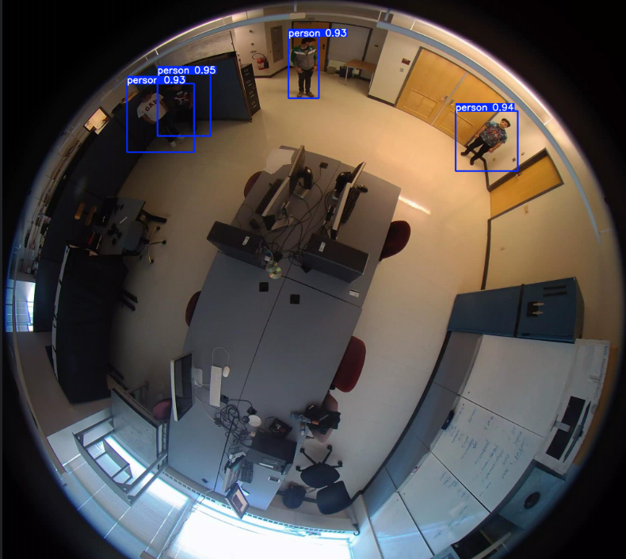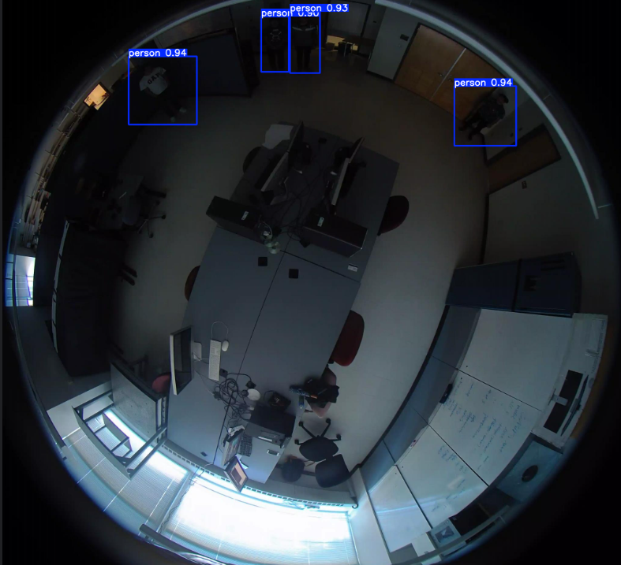

**Figure 9. YOLOv5 detection performance under varying lighting conditions.**

(a) Well-lit environment: High-confidence detections (p > 0.85) with precise bounding boxes.

(b) Low-light environment: Reduced confidence scores (p = 0.65–0.80) but maintained spatial accuracy.

**Live Tracking:**

To deploy Live tracking we experimented with 3 tracking pipelines.Each setup was evaluated based on identity consistency,visual clarity and ReID effectiveness.

1. **1.Approach : DeepSORT Default configuration for tracking**

Easy to set up but resulted in jittery inaccurate tracks and Frequent ID changes due to detection noise and inadequate ReID capabilities.

1. **Approach: DeepSORT + supervision:**

This approach yielded better results with cleaner tracking and better layout however the bounding box and text sizes were often distracting and it struggled with ReID.

1. **Approach: ByteTrack + supervision:**

It was the hardest to set up.Additionally, we tried a different layout using supervision. This layout was much cleaner and solved the issue of the distracting IDs and boxes.While this approach has better ReID it struggled with accurate detection.

**Final Approach:DeepSORT + ReID + supervision:**

Finally we decided to use DeepSORT enhanced with a ReID model to improve accuracy and supervision for layout.This approach enables best ID preservation out of the 4 approaches , and flexible layout customization. It offers the best tradeoff between simplicity and ReID performance.

**Figure 10: Approach 1 Figure 11: Final Approach**

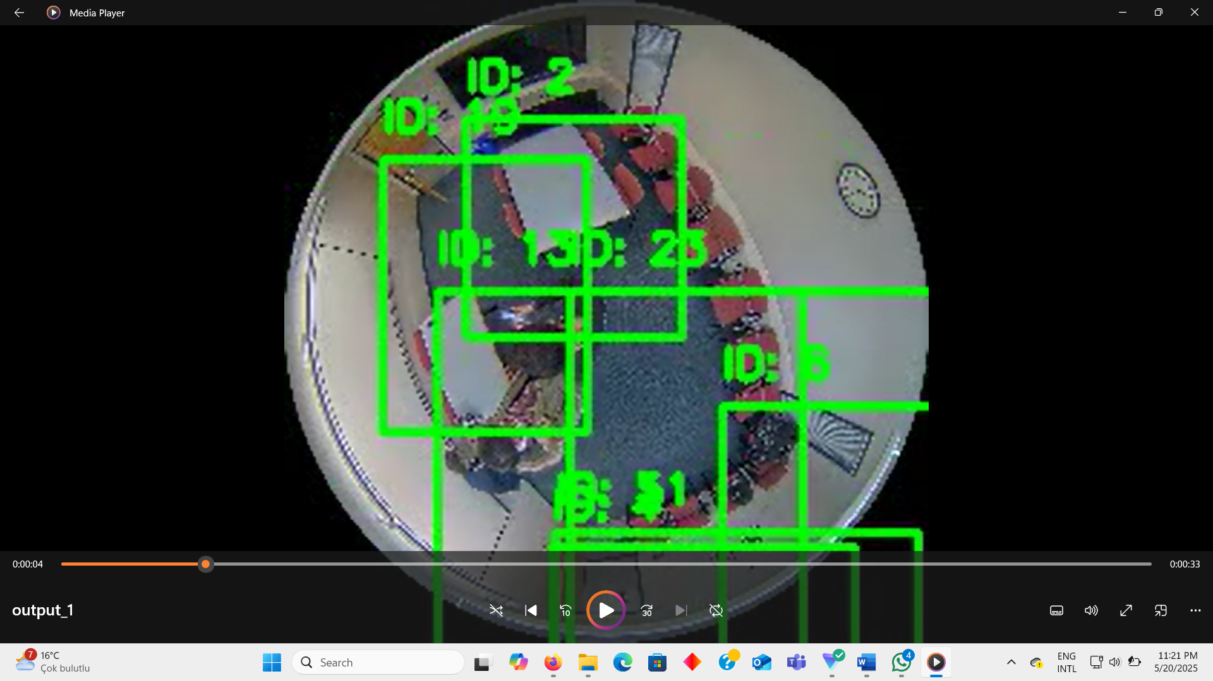 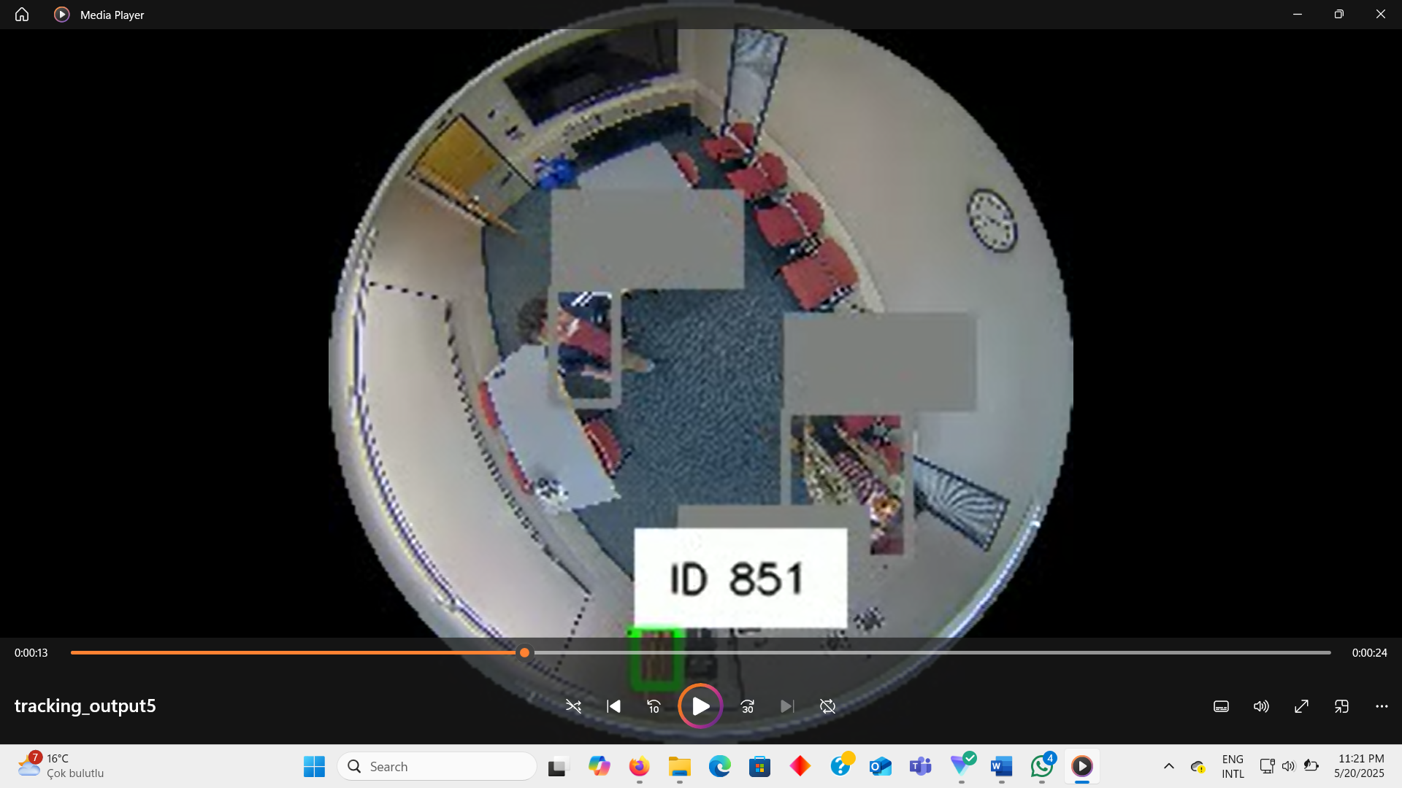

**Heatmap Generation For Crowd density:**

While Continuing to improve our models accuracy we simultaneously began developing a real time heatmap generation function.This function was built using a custom YOLOv5 for person detection and was based on an open source implementation from the repository CrowdMap[11] which was modified for our case.

The development process starts with frame by frame detections using YOLOv5 where detection and bounding boxes are extracted followed by generating a 2D gaussian kernel centered on the detected persons location on a grid. To enhance interoperability the grid or map is colored and normalized using OpenCVs COLORMAP_JET.This colored heatmap is blended with the original frame to produce an overlay visual that combines raw scenes with density insights.

* heatmap.jpg
* overlay.jpg
* boundingbox.jpg
* An optional video showing the heatmap stream.

**Figure 10: heatmap generation output model 1**

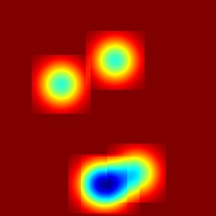 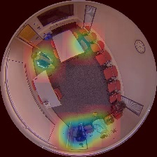 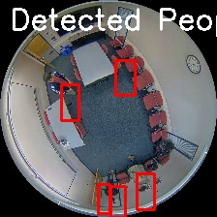

### 3.2.6. Evaluation

The initial YOLOv5 model faced challenges with bounding box shifts caused by object rotation, which led to inaccurate detections and tracking instability. To solve this issue we tested several alternatives including an MMRotate model which achieved mAP of 0.90.However, the final refined YOLOv5 model outperformed MMRotate in detection accuracy and offered a simpler, easier-to-implement setup.

By transforming the label format from rotated to axis aligned. The YOLOv5 model produces more accurate detections with minimal position drift.This enhances tracking stability and reduces jittering and ReID switches.The system supports live tracking and heatmap generation where blue regions correspond to higher crowd density.Additionally, users have the option to save the tracking and heatmap results for further analysis.

# 4. INTEGRATION AND EVALUATION

## 4.1. Integration

The Electrical and AI subsystems are combined during the integration phase to form a unified system for real-time room occupancy monitoring. The AI subsystem, initially intended to run on an NVIDIA Jetson Nano, will communicate with the Electrical subsystem which includes cameras, sensors, and an Arduino.The Electrical subsystem is responsible for setting up the cameras and sensors for recording room entry and exit events.while the AI subsystem processes the data and runs object detection, live heatmap generation and tracking.e to compatibility issues and limited memory on the Jetson Nano, all AI processing will be performed on a PC. The jetson will send live feeds to the PC and receive and display the results on the jetson monitor. This will be done through FastAPI/FLASK app and a uvicorn server. During integration, we first attempted to install and run our entire Python/OpenCV/YOLOv5 inference stack directly on the NVIDIA Jetson Nano, only to discover that its legacy Linux distribution lacked compatible library versions and package repositories; unable to resolve dependency conflicts, we then tried linking the Nano to our development laptops via SSH and USB-over-IP, but persistent driver mismatches and OTG compatibility issues prevented reliable remote execution. In a third effort, we connected a keyboard, mouse, and HDMI display to the Nano and convened a setup session in our university lab, where local firewall and proxy restrictions blocked the device’s internet access and thwarted online package installation. We also experimented with MMRotate’s R3Det rotated-object detection implementation on the Nano, its training would run for roughly 40 minutes before exhausting memory and crashing, so we abandoned that route as well. Undeterred, we transferred the complete application folder from our Windows environment onto the Nano using a USB flash drive, yet filesystem permission errors and unresolved runtime dependencies again led to build failures. After exhausting these trials, we decided to offload all AI inference processing to a dedicated PC-based server, where dependency management proved straightforward, while retaining the Jetson Nano exclusively for raw data capture, sensor interfacing, and video streaming.

## 4.2. Evaluation

The NVIDIA Jetson Nano was successfully set up and integrated into the system. The sensors developed by the Electrical team function as expected, providing reliable data for occupancy monitoring.

The YOLOv5 object detection model demonstrated excellent performance, achieving a high training mAP of 0.995, indicating both accuracy and speed suitable for real-time applications.

Live object tracking was effectively implemented using DeepSORT with Re-identification (ReID) and the Supervision framework, resulting in stable and consistent tracking of individuals across frames.

Heatmap generation was also successfully integrated, with blue regions clearly indicating crowded areas, providing an intuitive visualization of occupancy density.

Overall, the system meets the design goals for accuracy, speed, and usability in real-time room occupancy monitoring.

# 5. SUMMARY AND CONCLUSION

1. This project integrated the Electrical and AI subsystems to create a real-time room occupancy monitoring system.The Electrical team successfully developed and setup the sensors and cameras, while the AI subsystem trained a YOLOv5 model for fast and accurate object detection. By combining YOLOv5 with DeepSORT tracking and heatmap visualization, the system can reliably detect, track, and visualize occupancy density in real time. Despite initial challenges with label format and after trying multiple alternatives.YOLOv5 was successfully trained (mAP 0.995).Another challenge was processing limitation and compatibility issues on the NIVIDIA jetson.solution such as offloading AI processing to a PC ensured stable and accurate tracking performance. To um up,the project met its objectives of delivering an effective, efficient, and user-friendly occupancy monitoring solution. Future work could focus on running the system only on jetson and improving ReID in extremely crowded settings.

# ACKNOWLEDGEMENTS

We wish to thank our advisers prof. Fatih kahraman and prof.Arif Ergin . Also acknowledge any other help/support from friends, technicians and other staff etc...

This work was partly/wholly funded by Bahçeşehir University

We wish to express our sincere gratitude to our advisers for their invaluable guidance, cand insightful feedback throughout the course of this project. We acknowledge **Bahçeşehir University** for providing the resources and facilities that enabled us to complete this project successfully.

# REFERENCES

1. Axis Communications, “AXIS M3058-PLVE Network Camera - Support Resources,” Accessed: Nov. 21, 2024. [Online]. Available: <https://www.axis.com/products/axis-m3058-plve/support#support-resources>
2. Avigilon, “Avigilon Security Cameras,” Accessed: Nov. 21, 2024. [Online]. Available: <https://www.avigilon.com/security-cameras>
3. K. Sun, X. Wang, T. Xing, S. Liu, and Q. Zhao, "High-accuracy occupancy counting at crowded entrances for smart buildings, <https://www.sciencedirect.com/science/article/pii/S037877882400625X>
4. Kim, J., Choi, A., Moon, H. J., Moon, J. W., & Sung, M. (2023). Occupancy estimation using IoT sensors and machine learning: Incorporating ventilation system operating state and preprocessed differential pressure data. <https://www.sciencedirect.com/science/article/pii/S0360132323010065?via%3Dihub>
5. J. Yun, D. Kim, D.M. Kim, T. Song, J. Woo, Gan-based sensor data augmentation: application for counting moving people and detecting directions using pir sensors, Eng. Appl. Artif. Intell. 117 (2023) 105508. <https://www.sciencedirect.com/science/article/pii/S0952197622004985>
6. Atlassian, “Heatmaps: The complete guide to heatmaps,” *Atlassian*, Accessed: Nov. 21, 2024.

<https://www.atlassian.com/data/charts/heatmap-complete-guide>

1. Viso.ai, “Object tracking: Complete guide to deep learning object tracking,” *Viso.ai*, Accessed: Nov. 21, 2024.

<https://viso.ai/deep-learning/object-tracking/>

1. S. Li, M.O. Tezcan, P. Ishwar, and J. Konrad, “Supervised people counting using an overhead fisheye camera”, *IEEE International Conference on Advanced Visual and Signal-Based Surveillance (AVSS)*, Sept. 2019
2. MMRotate Contributors, “MMRotate: Rotated Object Detection Based on PyTorch and MMDetection,” *OpenMMLab Technical Report*, 2023. [Online]. Available:<https://mmrotate.readthedocs.io/en/latest/intro.html>
3. **Ultralytics**, *YOLOv5 Documentation*. 2023. [Online]. Available: <https://docs.ultralytics.com/models/yolov5/>. [Accessed: April 15, 2025].
4. K. Somani, *CrowdMap*, GitHub repository, [Online]. Available <https://github.com/kr1shnasomani/CrowdMap>,

Use the **IEEE style** when listing references. Try to add MINIMUM 10 references.

*A good guide can be found here:* <http://libguides.murdoch.edu.au/IEEE/>,

and many examples here: <https://libguides.murdoch.edu.au/IEEE/all>

# APPENDIX A

*Information that does not fit naturally into the main body of the report can be put into an appendix. Typically this would be long sections of software code, product user manuals, large tables of validation results, etc.*

*An example of providing source code is shown in this appendix. Display the source code in a* monospace (fixed-width) *font and single-spaced.*

*Alternatively give a link to an online code repository.*

Code for packing (and unpacking) an occupancy value [0,1] into an unsigned char.

// maximum error = +-0.25% (standard dev. = 0.5/sqrt(12)

// 0% and 100% occupancies are stored exactly.

unsigned char occByte;

if (occ==0.0) { occByte = 254; } // 0% occupancy stored exactly

else if (occ==1.0) { occByte = 255; } // 100% occupancy stored exactly

else { occByte = int(occ*200.0); }

// unpack occupancy

float occFlot;

if (occByte==254) { occFlot = 0.0; }

else if (occByte==255) { occFlot = 1.0; }

else { occFlot = (occByte+0.5)/200.0; }

# APPENDIX B

**Figure B.X:** YOLOv5s Training Log Output

*Epoch-wise training and validation loss values captured during 50-epoch training of YOLOv5s model using Google Colab with CUDA support.*